1. Draft an SQL query (in T-SQL) that would return all fields in the Values table and also pull in the Account, Entity and Upload descriptions.

*This assumes it is in correct database*

SELECT DISTINCT A.AcctDesc, E.EntDesc, L.UploadDesc V.\*

FROM Values V

INNER JOIN AccountDetails A ON A.AcctID = V.AcctID

INNER JOIN EntityDetails E ON E.EntID = V.EntID

INNER JOIN UploadDesc L ON L.LogID = V.LogID

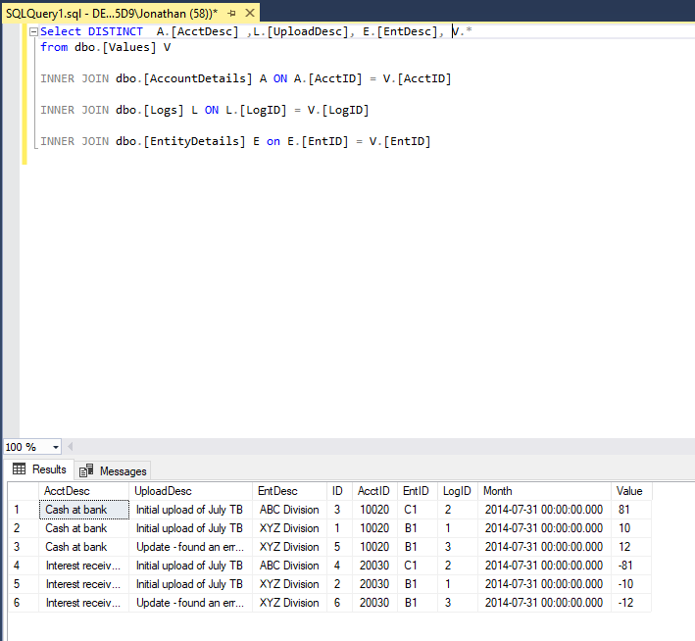

1. Describe how you would use the logs table to query the most recent data available in the database for each entity/account/month combination.

Assuming TimeStamp data is stores into the database as date/time type data (as it is being logged as an event happens and is datetime type in excel file – though CONVERT could be used to change it if not), then I would only need to perform an inner join (like above) and do an ORDER BY TimeStamp DESC.

If you wanted only the most recent data (using already joined data), I would select the relevant information (ID and max(TimeStamp) and then join that to the data where ID = ID and TimeStamp = max(TimeStamp) so that the only case in data would be most recent.